Breast Cancer Biomarker Assistant

Results Report

## Sequence 1

### Fasta Header:

>NC_000017.11:c43125364-43044295 Homo sapiens chromosome 17, GRCh38.p13 Primary Assembly

### Analysis Time:

3.5 seg

### Explainable Neural Network Model

Enabled

### Test results:

The results for the test are presented in table 1. This table only posts results with an accuracy above 30%. Any matches under the threshold are considered noise caused by arbitrary similarity in sequences due to the reduced vocabulary of nucleotides

|  |  |  |
| --- | --- | --- |
| Biomarker | Type | Likelihood: |
| BRCA1 | DNA | 0.96 |
| BRCA2 | DNA | 0.47 |

### Explainable Neural Network Model

#### Activated Neurons: Neuron Attribution

This graph represents the attribution and importance given to the neurons of a model.

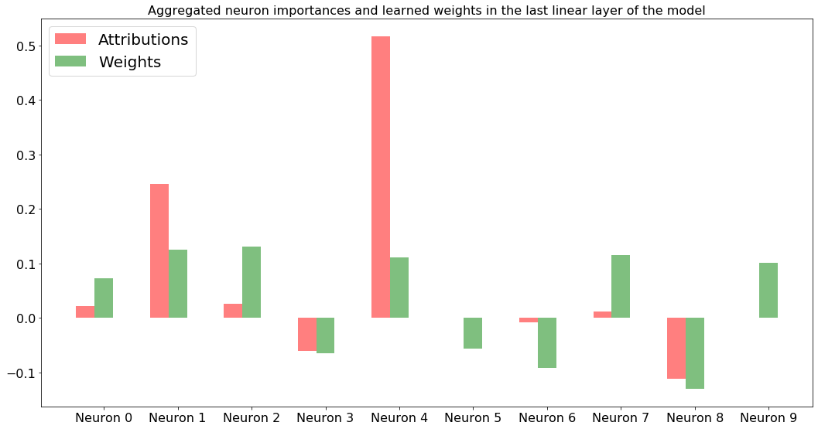

#### Neural Network Diagram

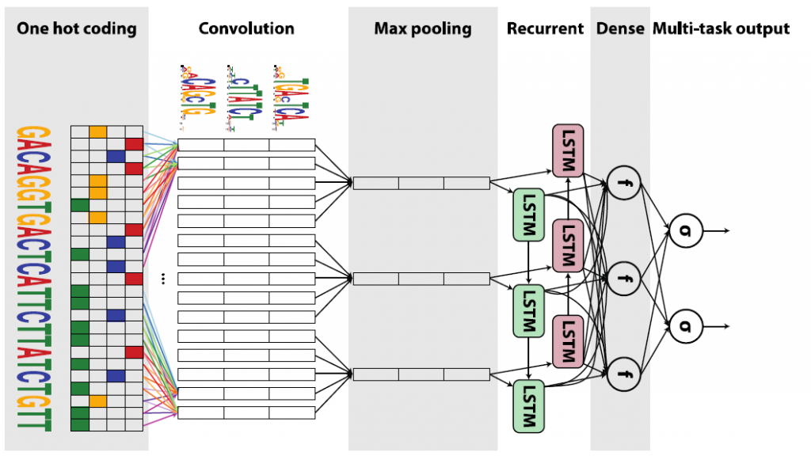

## Sequence 2

### Fasta Header:

>NC_000017.11:c43125364-43044295 Homo sapiens chromosome 17, GRCh38.p13 Primary Assembly

### Analysis Time:

3.5 seg

### Explainable Neural Network Model

Enabled

### Test results:

The results for the test are presented in table 1. This table only posts results with an accuracy above 30%. Any matches under the threshold are considered noise caused by arbitrary similarity in sequences due to the reduced vocabulary of nucleotides

|  |  |  |
| --- | --- | --- |
| Biomarker | Type | Likelihood: |
| BRCA1 | DNA | 0.96 |
| BRCA2 | DNA | 0.47 |

### Explainable Neural Network Model

#### Activated Neurons: Neuron Attribution

This graph represents the attribution and importance given to the neurons of a model.



#### Neural Network Diagram

